# Image result for nust logo

# **Department of Computing**

# **Advanced Programming (3+1)**

# **Instructor: Dr. Sidra Sultana**

# **Class: BSCS-7A**

# **Assignment # 01**

# **Date: 15 September,2019**

**Submitted by:**

**Muhammad Nouman Imran (215192)**

## **Assignment # 1 - Exploring Open Source Software**

|  |  |
| --- | --- |
| Assignment 1: Exploring Open Source Software | |
| CLO 3: Develop applications and tools using various frameworks | |
| Maximum Marks: 10 | Instructor: Dr. Sidra Sultana |
| Announcement Date: 4st Sept 2019 | Due Date : 16th Sept., 2019  11:30 pm on LMS |

Instructions:

1. Creativity shall be awarded.
2. Uniqueness is to be ensured.

Tasks:

Main purpose of the assignment is to familiarize the students with Open Source Software’s.

Do the following tasks:

1. Configure any open source software (OSS) like WordPress, Drupal, joomla, magento etc.
2. Explore it with user perspective.
3. Understand the database and coding structure.
4. Use some online available plugins or modules of respective OSS.
5. Document your learning in a single descriptive manual.

**Open Source Software’s**

**October CMS**

1. **Configuration and Selection of Open Source Software (OSS)**

I selected the **October CMS** for the following reasons:

* 1. It is lightweight.
  2. It is efficient.
  3. It is built on Laravel Php framework.
  4. It is easier to use.
  5. It is very friendly to developers and clients.
  6. You can do everything in the admin area besides moving back and forth like in the WordPress OSS.

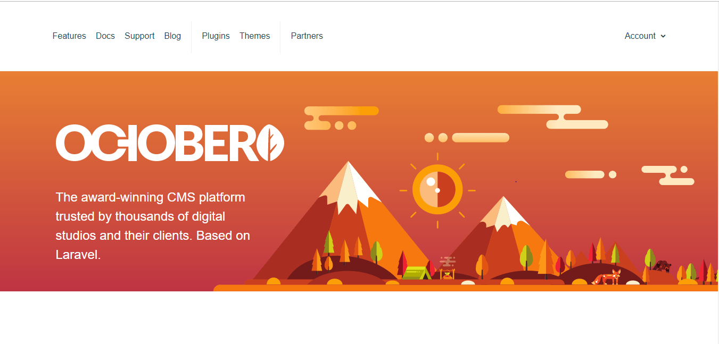

It is build on Php laravel framework so we require some localhost to use it. It requires PHP installed on your PC. I am using xammp for this purpose.

**Installation of October CMS:**

**October CMS** can be installed through wizard and CLI installation.

I used Wizard Installation because it’s easier and requires less technical skills of CLI commands.

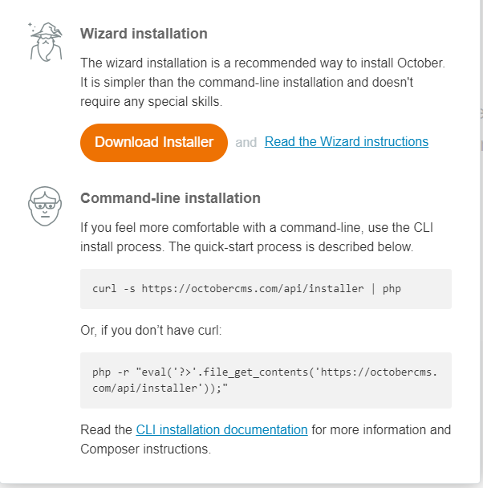

After downloading the October CMS, it is present in a zip file. On extracting it shows a bunch of files including install files folder, .gitignore file, install.php file which is used to install the CMS and a README file.

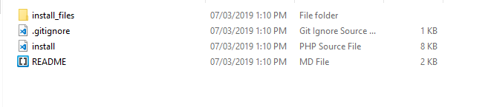

**Uploading the install.php script to Xammp**

Create a new folder by going into the C: drive >> Xammp >> htdocs and name it as AP Assignment. Just paste the install.php and install files folder. Ignore the .gitignore and README file. After pasting the files, open the file on the localhost with the following address: <http://localhost/Advanced/install.php>

**October CMS** will then start some checks for availability of important files including PHP 7.1.

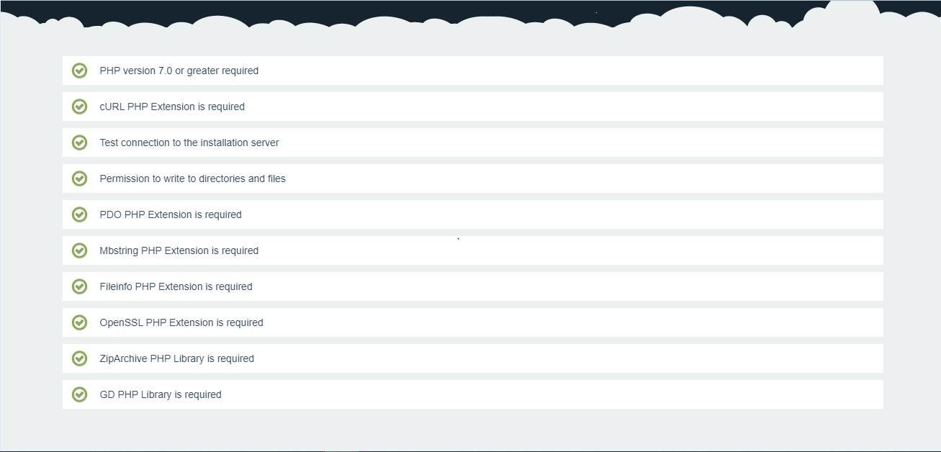

**Setting up Database Options**

It will then ask for database installation and setup. I will MySQL as database. Other options include SQL lite, Postgres and SQL Server. Setup the username and password for the database.

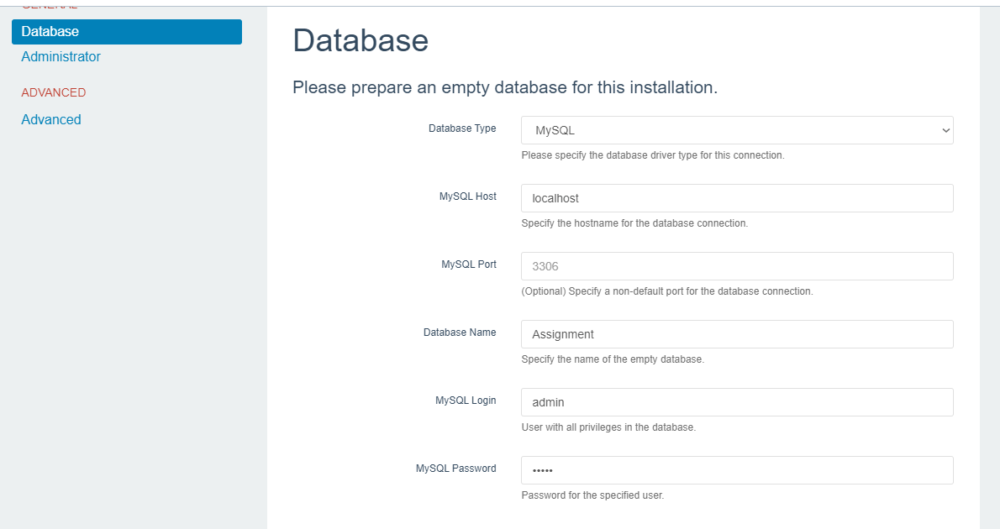

**Setting up Admin Options**

Now select the admin name, password and email for the administrator of the website or CMS.

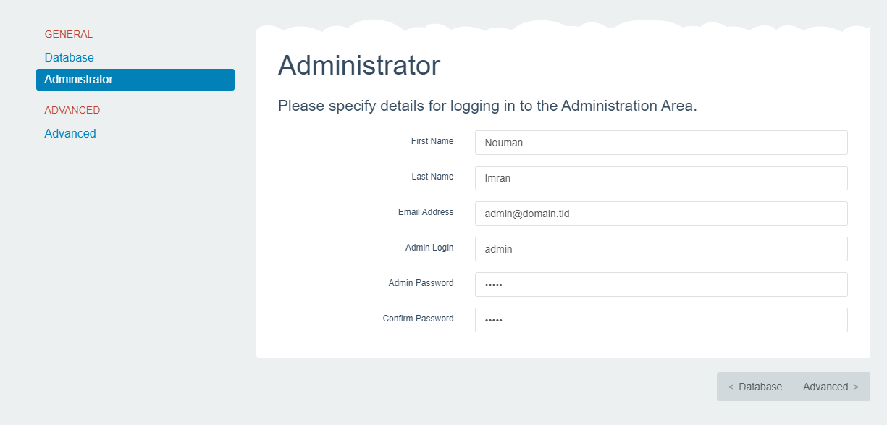

**Getting Started with October CMS**

After the database and admin installation, the CMS is good to go. It gives three options to start the project i.e. from scratch, using a theme or importing an already available project. I start using a theme which is bootstrap 4 theme available in the CMS library.

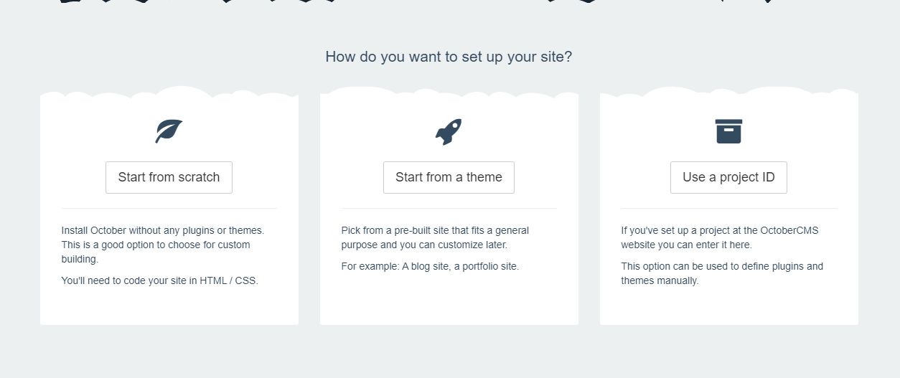

Install the theme by hitting install.

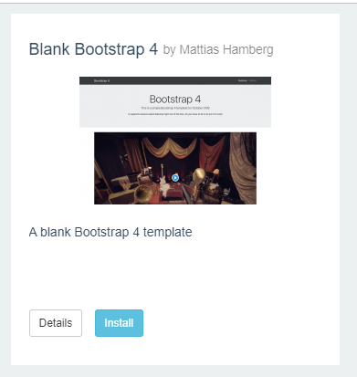

After installing the theme, go to the website URL at this address:

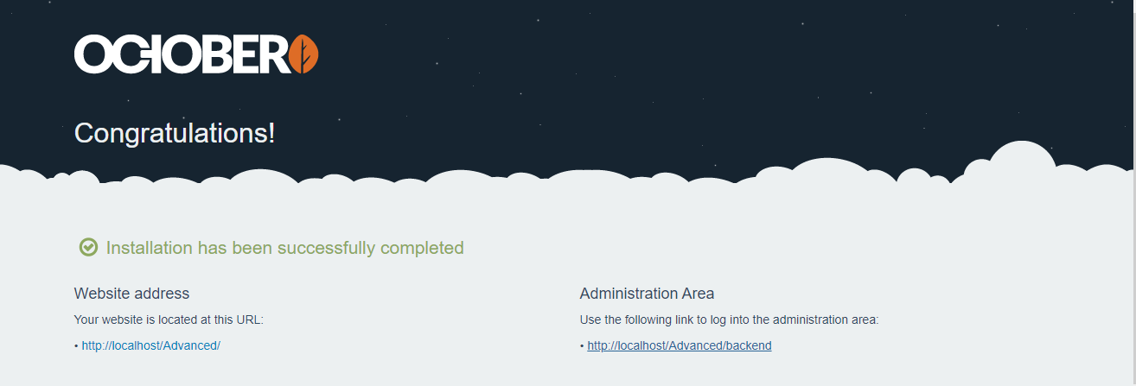

The website looks like this:

1. A Nav bar
2. A jumbotron area
3. A video section
4. Some text in table
5. Two pages

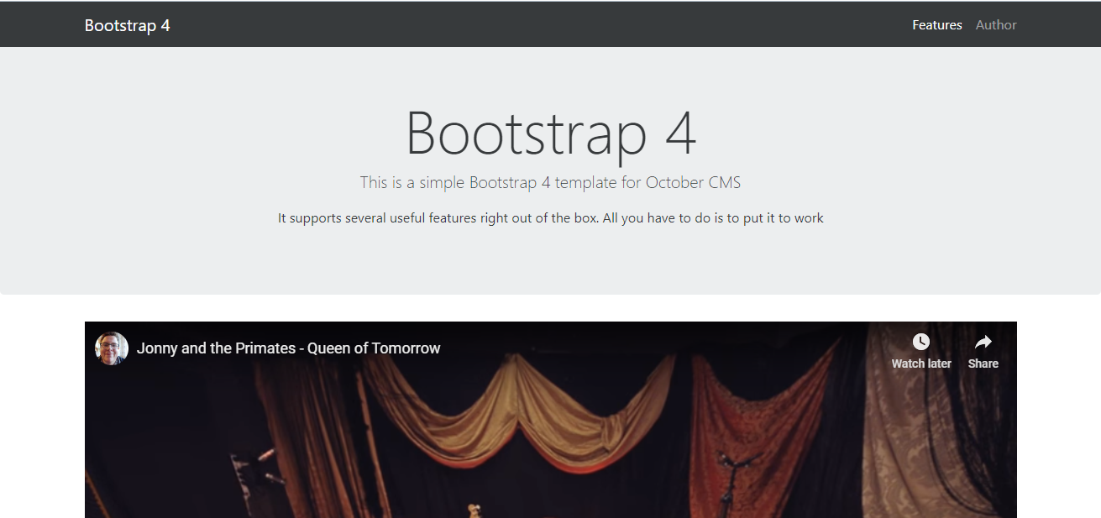

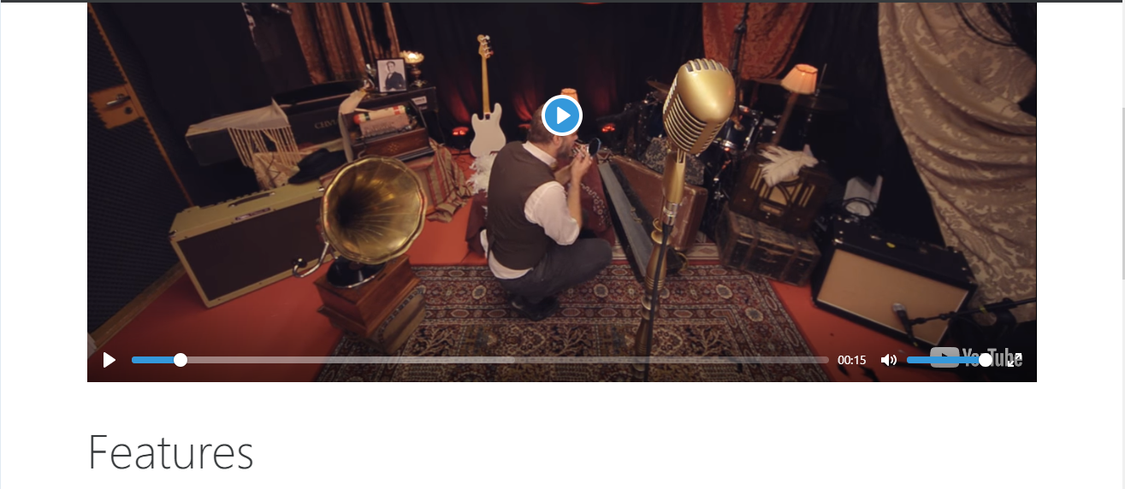

Go to the backend through the following address:

<http://localhost/Advanced/backend/backend/auth/signin>

Authorize the admin name and password and it will be directed to the Dashboard.

The Dashboard is just an entering window. It tells you about the themes, important updates and some other useful stuff related to admin like last sign in.

**CMS** is the main area for **users** and **developers** to customize site.

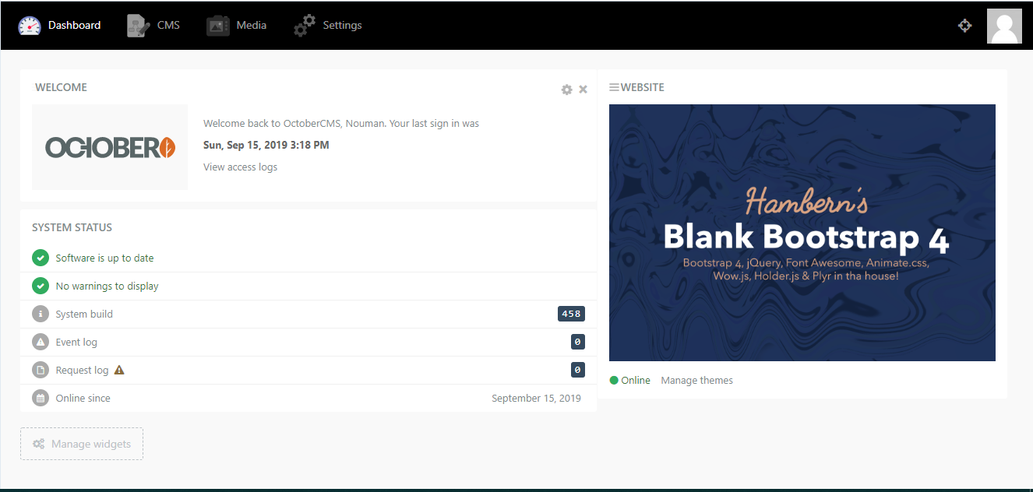

1. **Explore it with user perspective**

In the CMS options, there are different options available to customize the theme. These include:

1. Pages – You can add or delete pages and also customize their layout, name and meta tags and meta description which are important for Search Engine Optimization.

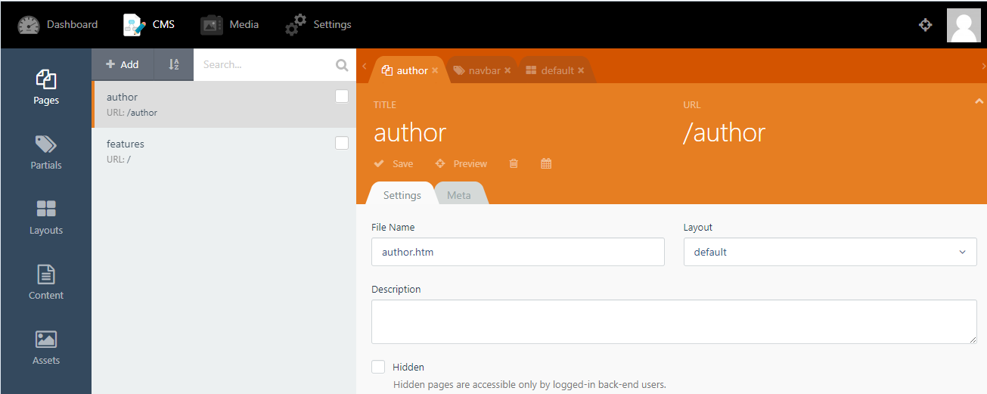

1. Layout – You can customize the layout here.
2. Partial – These are the sub components of the website like the navigation bar, header and footer. You can also make your own partials and add them in the website.

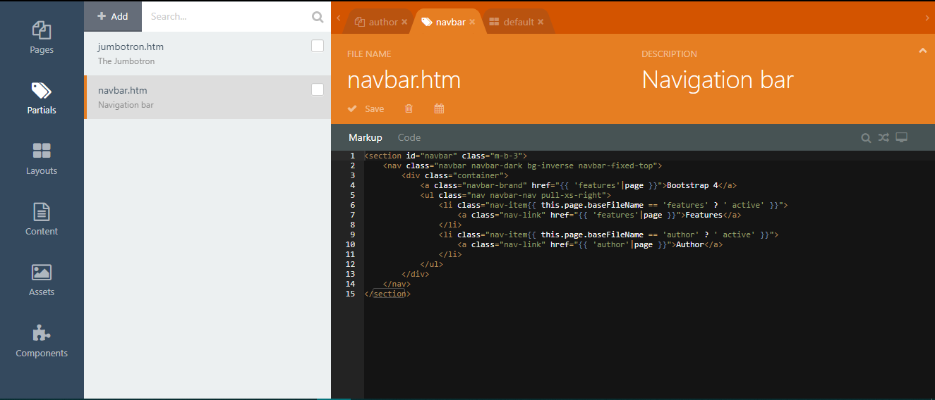

1. Content - You can add new content from here.
2. Assets – These are the images, CSS and JS files present in the website.
3. Component - You can add various pieces of code to make your site interactive, adds more functionality to the site. Add plugins to site.

At the end of each menu option, you have the coding screen to add some code or HTML markup to the pages. It uses Emit Text Editor to edit and add markups and code.

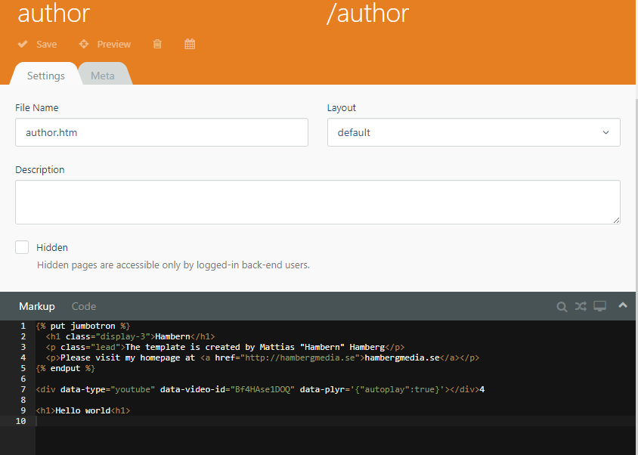



**Adding Pages**

Add pages by clicking add option on the page menu. Similarly, Delete the pages by selecting them and pressing delete option. To add content to the site use the HTML markups to add data to the site.

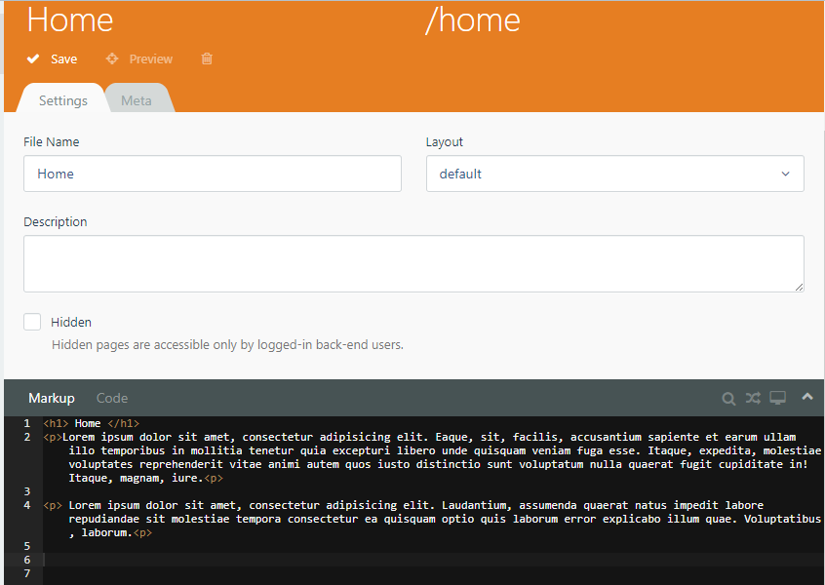

Similarly, you can add the content to the pages by selecting the page or making a separate blog page for adding content.

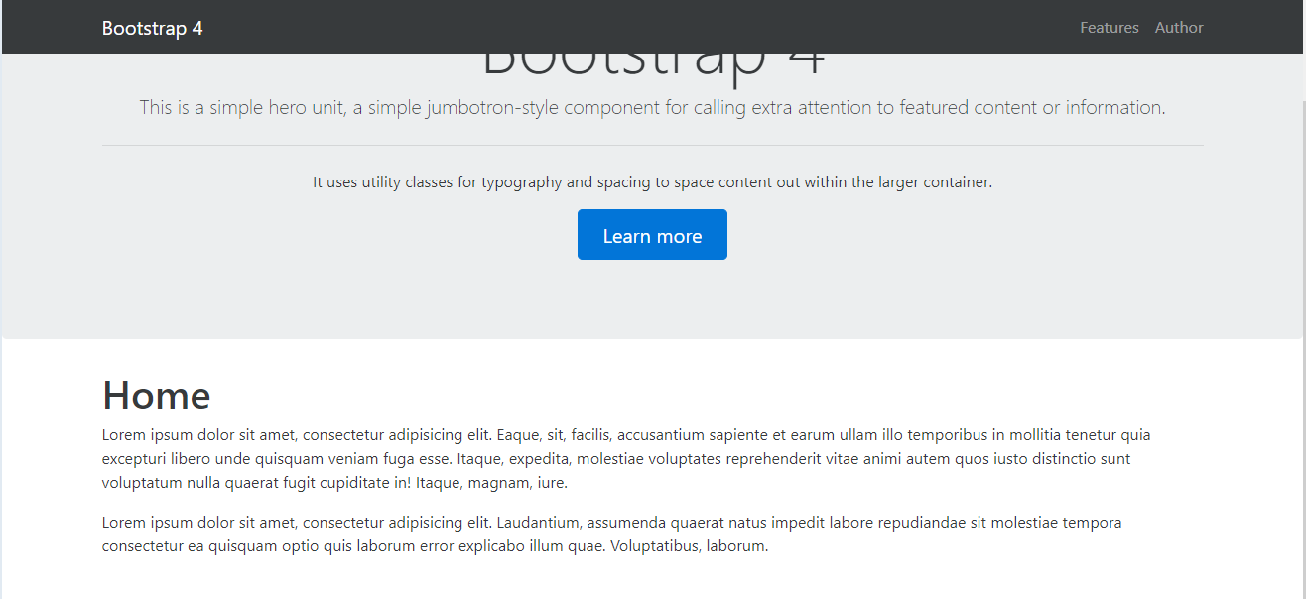

1. **Understand the database and coding structure.**

**Coding structure:**

The code can be easily edited by using the Emit Text Editor which is really efficient in updating the HTML markups and code on every page of the website.

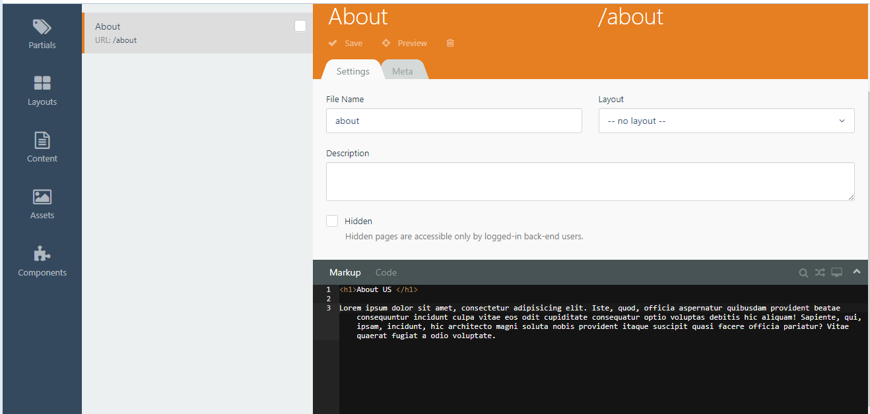

The CMS consist of the following folders to work with:

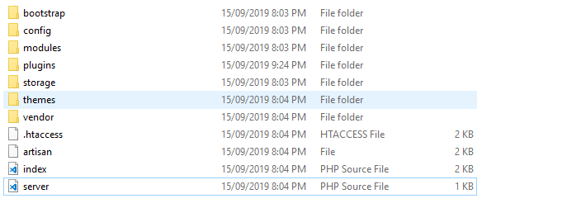

The config file - contains the important PHP scripts like

1. Database – This script is used to maintain the connection between the database and the website.

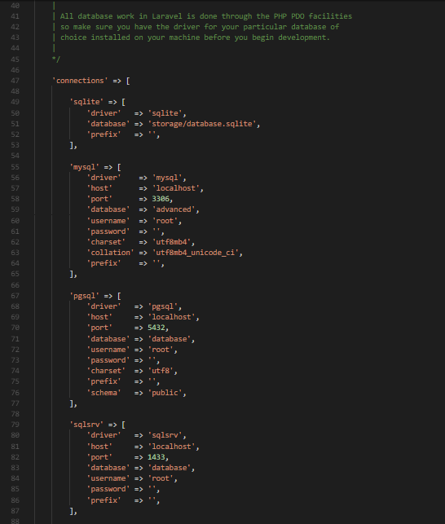

1. Cookie and session
2. CMS

The database configuration is located in the config/database.php file. In this file you may define all of your database connections, as well as specify which connection should be used by default.

### **Running raw SQL queries**

To run a basic query, we can use the select method on the DB facade:

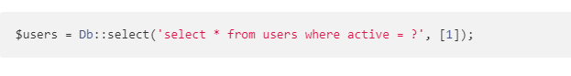[1]

Entire **October CMS** coding is in PHP framework **Laravel**. To edit your child theme, download the theme, edit theme and then save it to see the changings…

**Database**

October is already connected to your localhost database.

It can be accessed by <http://localhost/phpmyadmin>.

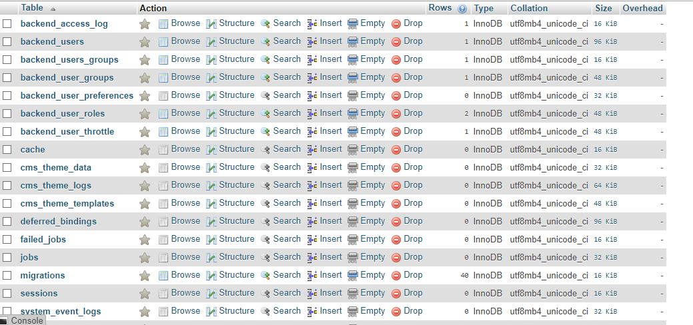

**SEO and Traffic**

SEO and traffic is one of the most important things for every Online business. To solve this issue **October CMS** provide the meta title and meta description fields on every page so you can optimize your content according to the related high Volume keywords…

It also provides the plugins like SEO Extension for this task…

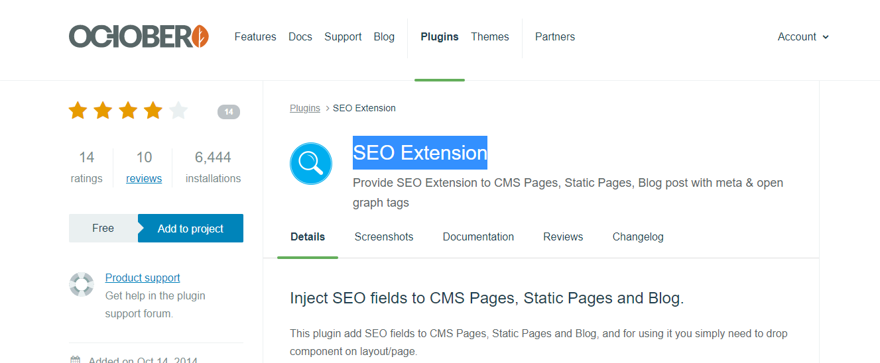

1. **Use some online available plugins or modules of respective OSS.**

**Installing Plugins**

As an example I will be installing the contact form plugin. Go to Systems >> Updates and Plugins

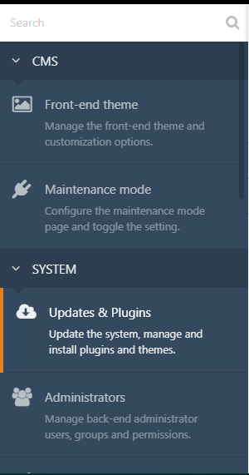

Now click on install plugins and search for contact form plugin:

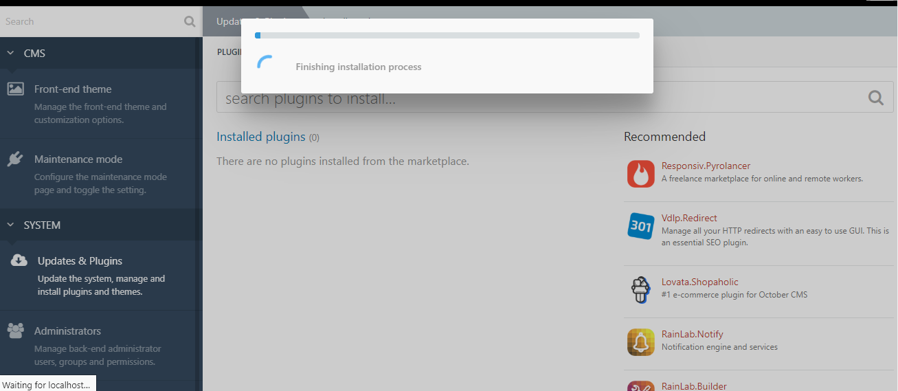

After installing the plugin, go to Contact US settings from the same menu under marketing:

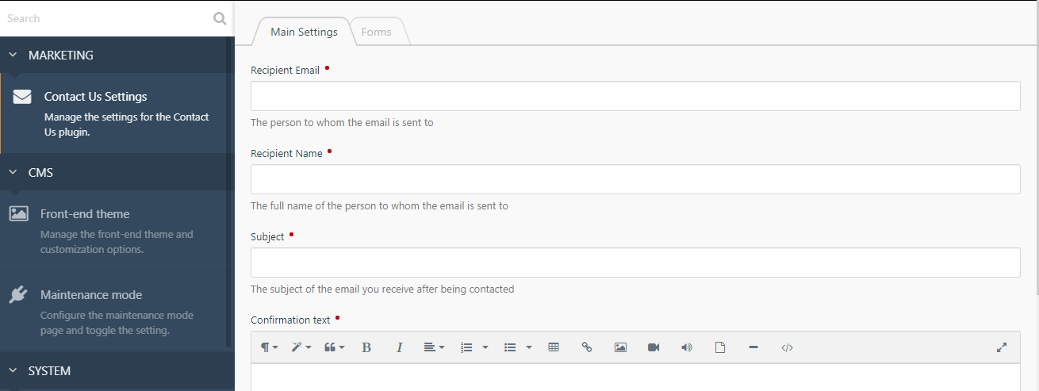

Add the data in the fields like recipient email, name and subject. You can also add the captcha key but you have to get site key and secret key before using this feature…

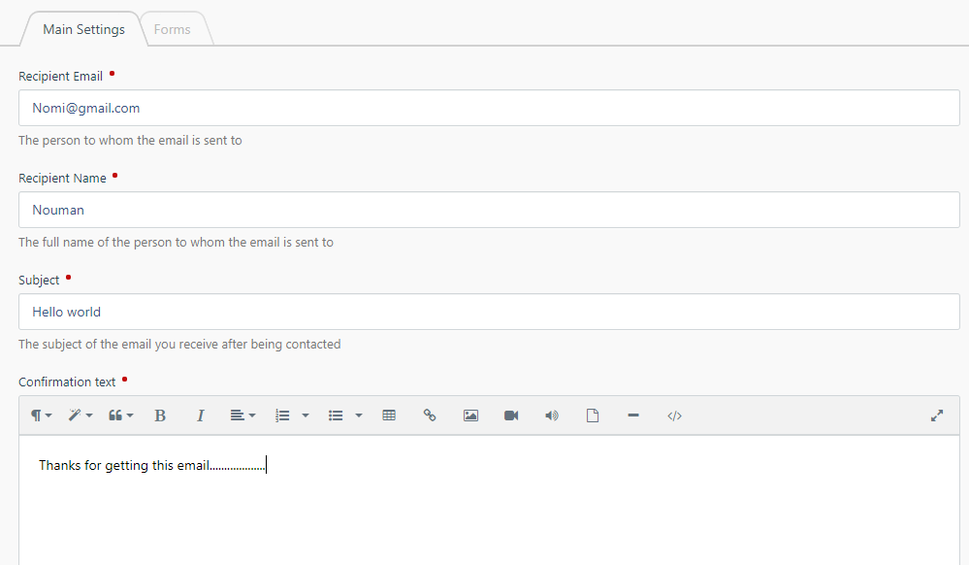

Save the settings and continue…

To add the plugin to the site go to CMS >> add new page >> Contact

Create a new page with the name contact and then go to Components to add the plugin to the site…

From Components select the Contact Us Form and it will embed the plugin to the site. To add the plugin use the shortcode of the plugin in the following format:

{% component ‘ //Shortcode here ’ %}

In this the code is:

{% component 'contactForm' %}

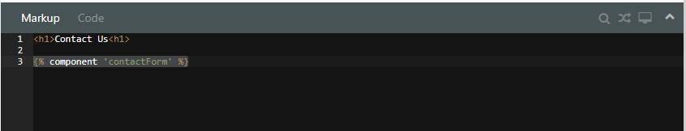

We can also add the more markup to the site using the HTML and code editor.

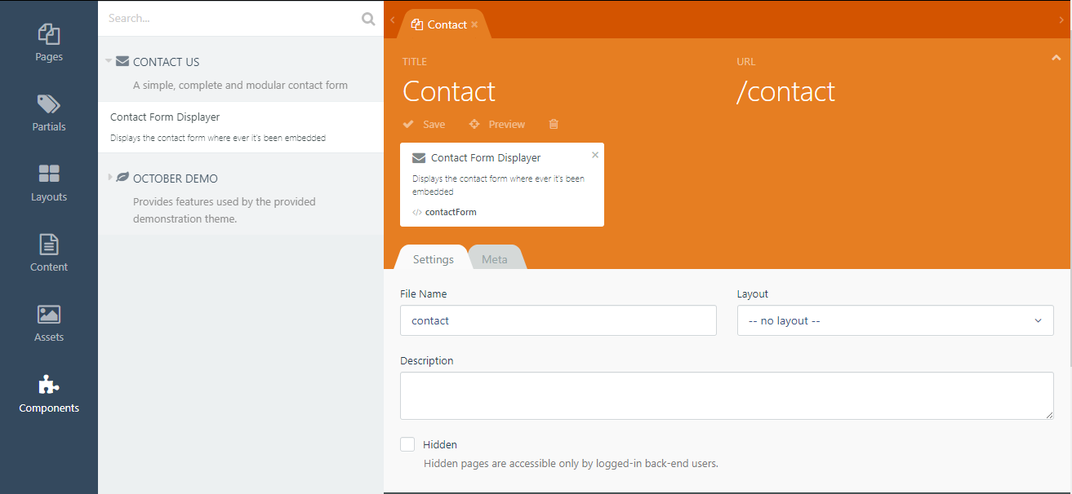

Now Go to the partials >> Navbar to add the contact us page to the site…

Then add the following code to add the page to the Navbar:

</li>

<li class="nav-item{{ this.page.baseFileName == 'contact' ? ' active' }}">

<a class="nav-link" href="{{ 'contact'|page }}">Contact</a>

</li>

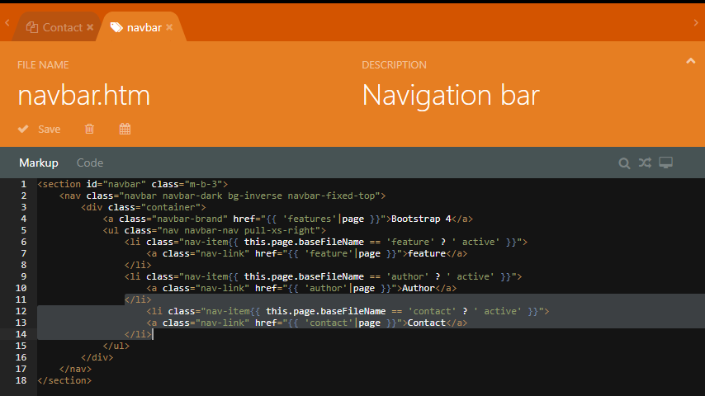

Reload the site and check the contact page:

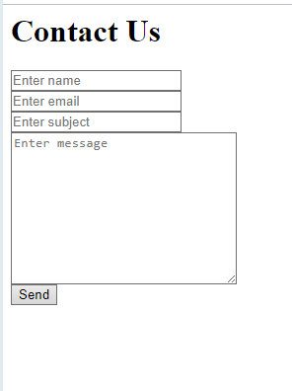

It now contains the contact form…

1. Image credits: <https://octobercms.com/docs/database/basics#database-transactions>